AGRIMART AI: A CONFIDENCE-AWARE DYNAMIC PRICING AND RULE-BASED SETTLEMENT FRAMEWORK FOR AGRICULTURAL SUPPLY CHAINS
A PROJECT REPORT
Submitted by
ROHAN R [REG. NO:31232104195]
PRAKASH M S [REG. NO:312323104171]
ALEXANDER R
in partial fulfillment of the award of the degree of
BACHELOR OF ENGINEERING
in
COMPUTER SCIENCE AND ENGINEERING

St. JOSEPH’S COLLEGE OF ENGINEERING
(An Autonomous Institution)
OMR, Chennai 600 119
ANNA UNIVERSITY : CHENNAI 600 025
APRIL 2026


ANNA UNIVERSITY, CHENNAI
BONAFIDE CERTIFICATE
Certified that this project report “AGRIMART AI: A CONFIDENCE-AWARE DYNAMIC PRICING AND RULE-BASED SETTLEMENT FRAMEWORK FOR AGRICULTURAL SUPPLY CHAINS” is the bonafide work of ROHAN R (312323104195), PRAKASH M S ( 312323104171) AND ALEXANDER R who carried out the project work under my supervision.

SIGNATURE  HEAD OF THE DEPARTMENT  Dr.V Muthulakshmi, M.E., Ph.D.,  Professor & Head of Department,  Dept. of Computer Science and Engineering,  St. Joseph’s college of Engineering,  OMR,Chennai-600 119 | SIGNATURE  SUPERVISOR  Mr. Alexander R, M.E.,(Ph.D).  Assistant Professor,  Dept. of Computer Science and Engineering,  St. Joseph’s college of Engineering,  OMR Chennai-600 119

Submitted to Project and Viva Examination held on ____________________
INTERNAL EXAMINER EXTERNAL EXAMINER


SDG CERTIFICATE
This is to certify that the project work titled “AGRIMART AI: A CONFIDENCE-AWARE DYNAMIC PRICING AND RULE-BASED SETTLEMENT FRAMEWORK FOR AGRICULTURAL SUPPLY CHAINS” has been successfully completed by ROHAN R [312323104195], PRAKASH M S [312323104171] and ALEXANDER R of B.E Computer Science Engineering, during academic year 2025 - 2026. This project aligns with the United Nations Sustainable Development Goals and mapped to the following Sustainable Development Goal(s) (SDGs):
SDG Number | Name | Brief Justification
SDG 2   | Zero Hunger | Strengthens the farm-to-market supply chain by giving farmers transparent price bands, reliable settlement and next-season crop advisory, supporting stable farm incomes.
SDG 8   | Decent Work and Economic Growth | Reduces post-commitment price disputes through auditable, rule-based settlement, promoting fair trade for farmers, wholesalers and drivers.
SDG 9   | Industry, Innovation, and Infrastructure | Develops an AI-driven, low-bandwidth digital platform that integrates forecasting, escrow and logistics for agricultural markets.
SDG 12   | Responsible Consumption and Production | Perishability-aware routing reduces spoilage and waste of produce in transit (10.5% versus 26.65% in the simulated baseline).
PROJECT SUPERVISOR HEAD OF DEPARTMENT

ACKNOWLEDGEMENT
At the outset, we would like to express our sincere gratitude to our beloved Dr. B. Babu Manoharan M.A., M.B.A., Ph.D., Chairman, St. Joseph’s Group of Institutions for his constant guidance and support to the student community and the Society.
We would like to express our hearty thanks to our respected Managing Director Mr. B. Shashi Sekar, M.Sc. for his kind encouragement and blessings.
We wish to express our sincere thanks to the Executive Director Mrs. S. Jessie Priya M.Com. for providing ample facilities in the institution.
We express sincere gratitude to our beloved Principal Dr. Vaddi Seshagiri Rao M.E., M.B.A., Ph.D., F.I.E. for his inspirational ideas during the course of the project.
We express our sincere gratitude to our beloved Dean (Research) Dr. A. Chandrasekar M.E., Ph.D., Dean (Student Affairs) Dr. V. Vallinayagam M.Sc., M.Phil., Ph.D., Dean (Academics) Dr. G. Sreekumar M.Sc., M.Tech., Ph.D. and Dean (School of Computing) Mrs. G. Lathaselvi M.E., (Ph.D) for their inspirational ideas during the course of the project.
We wish to express our sincere thanks to Dr. V Muthulakshmi, M.E., Ph.D., Head of the Department, Department of Computer Science and Engineering, St. Joseph’s College of Engineering for her guidance and assistance in solving the various intricacies involved in the project.
We would like to acknowledge our profound gratitude to our supervisor Mr. Alexander R, M.E.,(Ph.D).Assistant Professor, for their expert guidance and connoisseur suggestion to carry out the study successfully.

Finally, we thank the Faculty Members and our Family, who helped and encouraged us constantly to complete the project successfully.

ABSTRACT
This project presents AgriMart AI, a web-based, low-bandwidth decision-support platform for the agricultural supply chain that integrates uncertainty-aware price forecasting, explainable AI, rule-based settlement and perishability-aware vehicle routing with crop advisory. Price volatility, demand fluctuations, transportation delays, perishability, variable quality and post-delivery disputes between farmers and wholesalers are the major problems of this supply chain, and existing solutions deliver only point forecasts, with settlement and logistics treated separately. The forecasting layer of the proposed system is a Single-Layer Transformer Convolutional Encoder (STCE) that learns local temporal patterns and long-range dependencies from mandi prices, arrivals and related features, with a Long Short-Term Memory (LSTM) network as the benchmark. SHAP explains the predicted prices, a rule-based settlement engine determines the final agreed price within the previously agreed range, and a Vehicle Routing Problem with Time Windows (VRPTW) formulation considers crop perishability, delivery windows, vehicle capacity and driver reputation. On a real, unseen AGMARKNET dataset of Soyabean prices at the Itarsi mandi from 2008 to 2017, the STCE yields a MAPE of 2.55%, an RMSE of ₹120.23 per quintal and a prediction interval coverage of 92.35%, reported alongside an ARIMA(2,1,2) baseline and an LSTM-GRU ensemble, and a Monte Carlo simulation of 2,000 shipments evaluates the settlement and routing layers. The primary contribution is an auditable decision-making chain from quoting to commitment, negotiation, transport, quality checking and settlement, and on to the next season’s crop advisory.

TABLE OF CONTENTS
CHAPTER NO | TITLE | PAGE NO.
 | ABSTRACT | v
 | LIST OF FIGURES | ix
 | LIST OF ABBREVIATIONS | x
1 | INTRODUCTION | 1
 | 1.1 OVERVIEW | 1
 | 1.2 SCOPE AND OBJECTIVE | 2
 | 1.3 METHODOLOGY USED | 3
 | 1.4 DEEP LEARNING AND OPTIMIZATION ALGORITHMS | 5
2 | LITERATURE SURVEY | 7
3 | SYSTEM ANALYSIS | 13
 | 3.1 EXISTING SYSTEM | 13
 | 3.2 DISADVANTAGES OF EXISTING SYSTEM | 14
 | 3.3 PROPOSED SYSTEM | 15
 | 3.4 ADVANTAGES OF PROPOSED SYSTEM | 16
 | 3.5 FUNCTIONAL AND NON FUNCTIONAL REQUIREMENTS | 17
4 | SYSTEM DESIGN | 19
 | 4.1 USE CASE DIAGRAM | 19
 | 4.2 DATA FLOW DIAGRAM | 21
5 | SYSTEM IMPLEMENTATION | 23
 | 5.1 SYSTEM ARCHITECTURE | 23
 | 5.2 PREPROCESSING AND FEATURE EXTRACTION | 24
 | 5.2.1 DATA PREPROCESSING | 24
 | 5.2.2 FEATURE EXTRACTION | 26
 | 5.3 SINGLE-LAYER TRANSFORMER CONVOLUTIONAL ENCODER (STCE) MODEL | 27
 | 5.3.1 OVERVIEW OF STCE ARCHITECTURE | 27
 | 5.3.2 CONFIDENCE BAND GENERATION | 27
 | 5.3.3 EXPLAINABILITY AND PRE-COMMITMENT ESCROW | 28
 | 5.4 RULE-BASED SETTLEMENT ENGINE | 29
 | 5.5 PERISHABILITY-AWARE VRPTW AND DRIVER ASSIGNMENT | 30
 | 5.6 QUALITY VERIFICATION, SETTLEMENT AND ADVISORY | 31
6 | OUTPUT | 33
 | 6.1 PRICE FORECAST AND CONFIDENCE BAND | 33
 | 6.2 QUOTATION AND SETTLEMENT INTERFACE | 34
7 | RESULTS AND DISCUSSION | 36
 | 7.1 EXPERIMENTAL SETUP | 36
 | 7.2 PERFORMANCE METRICS | 37
 | 7.3 QUANTITATIVE RESULTS | 38
8 | CONCLUSION AND FUTURE WORK | 42
 | 8.1 CONCLUSION | 42
 | 8.2 FUTURE ENHANCEMENTS | 43
 | REFERENCES | 44
 | APPENDICES | 48
 | PRESENTED CERTIFICATE | 49
 | PUBLISH SITE PAGE | 50
 | PUBLISHED COPY | 51

LIST OF FIGURES
FIGURE NO | FIGURE NAME | PAGE NO
4.1 | USE CASE DIAGRAM | 19
4.2 | DATA FLOW DIAGRAM (FORECASTING AND QUOTATION) | 21
4.3 | DATA FLOW DIAGRAM (SETTLEMENT, LOGISTICS AND ESCROW) | 22
5.1 | SYSTEM ARCHITECTURE DIAGRAM | 23
5.2 | DATASET PREPROCESSING SUMMARY | 25
6.1 | OBSERVED VERSUS PREDICTED MANDI PRICE | 33
6.2 | SHAP-BASED FEATURE IMPORTANCE | 34
6.3 | PRICE QUOTATION AND SETTLEMENT INTERFACE | 35
7.1 | SETTLEMENT AND ROUTING EVALUATION | 40

LIST OF ABBREVIATIONS
AGMARKNET | Agricultural Marketing Information Network
ARIMA | Autoregressive Integrated Moving Average
GRU | Gated Recurrent Unit
LSTM | Long Short-Term Memory
MAE | Mean Absolute Error
MAPE | Mean Absolute Percentage Error
PWA | Progressive Web Application
RMSE | Root Mean Square Error
SHAP | SHapley Additive exPlanations
STCE | Single-Layer Transformer Convolutional Encoder
VRPTW | Vehicle Routing Problem with Time Windows
XAI | Explainable Artificial Intelligence

CHAPTER 1
INTRODUCTION

1.1 OVERVIEW
The upstream supply chain of agricultural commodities is exposed to persistent uncertainty. Prices fluctuate with market arrivals and seasonal demand, transportation is subject to delays, perishable produce deteriorates in transit, and the quality that reaches the buyer often differs from what was promised when the price was fixed. These factors create risk for both farmers and wholesalers. A price guaranteed before delivery may turn out to be unfavourable when the produce reaches the destination market, which leads to disputes, delayed claims and, in many cases, lower producer income.
Existing price prediction approaches for agricultural markets concentrate mainly on point forecasts and offer little support for uncertainty-sensitive commercial decisions [1]. In the same way, conventional logistics systems typically minimise transport cost or distance without taking into account the perishability of the produce, the prevailing market conditions or the reliability of the stakeholders involved [2]. Forecasting, negotiation, payment and logistics are therefore treated as separate problems, although in practice they strongly influence one another.
This project presents AgriMart AI, a web-based, low-bandwidth decision-support platform that brings price forecasting, negotiation, escrow and logistics into a single, auditable decision chain. A Single-Layer Transformer Convolutional Encoder (STCE) learns temporal and contextual relationships in mandi prices, market arrivals and related variables, and produces a load-specific price forecast together with a confidence band. A Long Short-Term Memory (LSTM) network is used as the benchmark for temporal forecasting performance. SHAP presents the key factors that drive each predicted price range, which improves transparency for agricultural stakeholders [3]. A rule-based settlement mechanism then determines the final price within the pre-agreed range, adjusting it for transit and market conditions, while a perishability-aware Vehicle Routing Problem with Time Windows (VRPTW) module assigns vehicles to loads by considering the deterioration of the produce and the reputation of the drivers. Quality-gated escrow supports responsible payment release, and past experience helps to guide crop planning for the next season [4].
Farmers and wholesalers need a secure and transparent mechanism to handle the uncertainty that arises around price commitment, farm delivery and final settlement. Point forecasts cannot represent the full range of possible market outcomes, and stand-alone logistics and payment tools do not capture the interconnected risks of agricultural trade. A single transparent system is therefore needed that combines uncertainty-aware forecasting, explainable decision support, adaptive negotiation, secure settlement and perishability-sensitive transportation. The motivation behind AgriMart AI is to reduce disputes over prices after commitment, to protect the value of transactions, to improve delivery decisions, and to provide an auditable trace from the quotation to the pay-out.

1.2 SCOPE AND OBJECTIVE
The overall aim of this project is to design, implement and evaluate AgriMart AI as an integrated framework that links agricultural price forecasting with rule-based settlement and perishability-aware logistics. The scope of the forecasting experiments is defined by a real, unseen dataset obtained from AGMARKNET, comprising the daily mandi prices of Soyabean at the Itarsi market (Madhya Pradesh) from January 2008 to June 2017. Because a full commercial deployment involves multi-stakeholder field adoption, the settlement and routing layers are evaluated through a controlled Monte Carlo simulation of 2,000 shipments, and the escrow used in the system is a software-managed simulated ledger and not a real financial transaction.
The specific objectives of the project are as follows. The first objective is to build an STCE-based agricultural price forecasting system that produces load-specific confidence-band estimates of prices from market, weather, demand, distance and route-related variables. The second objective is to develop an integrated settlement and logistics model that combines explainable AI, a rule-based settlement mechanism for price commitment, quality gating in escrow and VRPTW optimisation for perishable goods. The third objective is to build an audit trail for agricultural transaction workflows that provides robust evidence in price disputes, supports reliable transportation and transparent settlement, and supports next-season crop advisory.
The main contributions of the work are the following. An STCE forecasting architecture is introduced that represents uncertainty in agricultural prices as prediction intervals instead of simple point forecasts. SHAP explanations are combined with a rule-based settlement engine that determines the final settlement value under changing transit and market conditions while remaining within the agreed price window. The vehicle and delivery assignment is formulated as a VRPTW decision problem that includes crop perishability, route conditions and driver reputation. Finally, a low-bandwidth platform is provided that offers pre-commitment escrow, quality-gated payment release, forecasting, negotiation, logistics and crop advisory in one place, with traceability from quote to payout.

1.3 METHODOLOGY USED
AgriMart AI is realised as a modular web-service decision and transaction system, and its overall flow is shown in the system architecture of Chapter 5. The process is initiated with historical mandi prices and arrival information, to which weather, demand, distance, route and perishability information is added. From these inputs a load-specific price interval is generated. The interval is not merely a prediction shown to the user; it acts as the contractual boundary within which negotiation and settlement take place. The system is organised into seven modules that are described below.
The first two modules ingest and prepare the data. Daily mandi price records are pulled from the AGMARKNET feed and checked against the expected schema. Invalid records are filtered, gaps are interpolated and numerical features are normalised using training-set statistics only. The third module performs feature engineering and reduction, producing lagged prices, rolling statistics, arrival volume and calendar features while preserving the chronological order of the data.
The fourth module is the forecasting module. The STCE first applies a one-dimensional convolution over the sequential market features to extract local temporal patterns, and then applies a multi-head attention mechanism to capture long-range contextual relationships. The resulting representation is passed to a prediction block that produces a main forecast and a set of uncertainty intervals, constructed either by quantile regression or by Monte Carlo dropout. An LSTM trained on the same partitions serves as the recurrent benchmark.
The fifth module explains and quotes the price. SHAP quantifies the contribution of each input feature to the prediction, and the farmer receives a price range with an explanation instead of an ambiguous point estimate. After the farmer explicitly accepts the quotation before dispatch, the agreed amount is entered into a simulated internal escrow ledger. The sixth module is the rule-based settlement engine, which uses a deterministic, weighted-adjustment rule to compute the final settlement value inside the agreed band as transit and market conditions change. The seventh module handles logistics and reporting: a perishability-aware VRPTW model and a ranked driver assignment select vehicles and routes, delivery quality is verified, the simulated escrow is released according to the verified result, and the complete transaction is archived in an append-only audit log. The results are presented to the users through a Progressive Web Application (PWA).

1.4 DEEP LEARNING AND OPTIMIZATION ALGORITHMS
This project uses a combination of learning and optimisation algorithms to address three aspects of the problem: temporal forecasting, explainability and logistics. Each algorithm is specialised for one aspect, and their integration forms the basis of the AgriMart AI decision chain.
The Single-Layer Transformer Convolutional Encoder (STCE) is the primary forecasting architecture. A convolutional layer applied along the time axis extracts local temporal patterns from the sequence of market features, such as short-term price movements. A multi-head self-attention mechanism then relates every position in the sequence to every other position, which allows the model to capture long-range contextual relationships among historical prices, market arrivals, weather elements and load-specific attributes. Using a single encoder layer keeps the computational cost low, which is important for a platform intended to run with limited resources. The output of the encoder is fed to a prediction block that returns a point forecast together with prediction intervals.
Long Short-Term Memory (LSTM) networks are used as the recurrent forecasting benchmark. An LSTM is a type of recurrent neural network designed to overcome the limitations of simple recurrent networks in learning long-range dependencies. Its input, forget and output gates regulate the flow of information through the network, so that it can remember important patterns over long periods and discard irrelevant information. In the experiments, the LSTM is trained on the same training and validation partitions as the STCE, and a GRU and an LSTM-GRU ensemble are reported alongside it, together with a naive persistence baseline and an ARIMA(2,1,2) statistical baseline.
SHAP (SHapley Additive exPlanations) is used as the explainability layer. It is based on Shapley values from cooperative game theory and assigns to each input feature an importance value for a particular prediction [3]. In this project a gradient-based SHAP explainer is applied to the trained STCE model, giving global feature importance over the test set and, when read for a single shipment, the explanation of an individual quotation.
The logistics layer is an optimisation component and not a learned model. The Vehicle Routing Problem with Time Windows is solved with Google OR-Tools, which finds feasible and efficient routes under vehicle capacity, pickup and delivery locations, travel time and delivery deadline constraints. A Crop Perishability Index and a driver reputation ranking adjust the urgency and the priority of the assignment, so that the optimiser works on realistic delivery schedules for perishable produce.

CHAPTER 2
LITERATURE SURVEY
The prices of agricultural commodities show significant temporal variation because of production cycles, seasonal demand, weather, transportation restrictions and market arrivals. Forecasting systems have therefore become important for agricultural decision-support systems. The early methods were mainly statistical time-series methods, and more recent methods use machine learning and deep neural networks. The studies surveyed in this chapter provide the technical basis for applying predictive models to farm-to-market decisions, and they also show that statistical prediction accuracy is only the first part of the problem, because designing a workable transaction mechanism around this accuracy is far from straightforward.
[1] C. E. A. Bundak et al. “Computationally Efficient Single Layer Transformer Convolutional Encoder for Accurate Price Prediction of Agriculture Commodities” IEEE Access, 2025. This work proposes a computationally efficient Single-Layer Transformer Convolutional Encoder for agricultural commodity price prediction. A convolutional operation extracts local temporal patterns from the price series, while attention captures long-range contextual dependencies, and the single-layer design keeps the computational cost low. This architecture is the basis of the forecasting layer adopted in AgriMart AI, which extends it to produce prediction intervals instead of point forecasts alone.
[2] H. Wang et al. “Intelligent Distribution of Fresh Agricultural Products in Smart City” IEEE Transactions on Industrial Informatics, 2022. This study addresses the intelligent distribution of fresh agricultural products in urban settings, where perishable goods must be delivered within tight time limits. It supports the observation that logistics for agricultural produce cannot rely on cost or distance minimisation alone, and it motivates the perishability-aware routing module of the proposed system.
[3] S. M. Lundberg and S.-I. Lee “A Unified Approach to Interpreting Model Predictions” Advances in Neural Information Processing Systems (NeurIPS), 2017. This paper introduces SHAP, a unified framework for interpreting model predictions in which each feature is assigned an importance value for a particular prediction based on Shapley values. The framework provides the feature-level explanations that AgriMart AI uses to justify each quoted price range to farmers and wholesalers.
[4] S. P. Raja et al. “Crop Prediction Based on Characteristics of the Agricultural Environment Using Various Feature Selection Techniques and Classifiers” IEEE Access, 2022. This work predicts suitable crops from the characteristics of the agricultural environment by using feature selection techniques together with classifiers. It supports data-driven crop planning and provides the background for the next-season crop advisory module of the proposed platform.
[5] N. A. R. et al. “Intelligent deep learning framework for real-time agricultural price prediction using NBEATS-X” 2025 4th International Conference on Automation, Computing and Renewable Systems (ICACRS), 2025. A framework for real-time prediction of agricultural prices is explored using N-BEATS-X, a deep forecasting approach that is able to consider relevant temporal information in the prediction. The work shows the potential of deep forecasting models for agricultural markets.
[6] D. Chen et al. “A study on the forecasting of agricultural product price trends based on SARIMA” 2025 IEEE 8th Information Technology and Mechatronics Engineering Conference (ITOEC), 2025. Although statistical forecasting remains effective, this study uses the seasonal ARIMA model to represent the seasonal and sequential dependency in the price trends of agricultural products. It is relevant to this project because an ARIMA(2,1,2) model is one of the baselines against which the STCE forecaster is compared.
[7] M. Xia “Machine learning-based agricultural product price fluctuation prediction and supply chain risk mitigation strategies” 2026 3rd International Conference on Integrated Intelligence and Communication Systems (ICIICS), 2026. Machine learning is used for the prediction of agricultural product price fluctuations and for reducing risk in the agricultural supply chain. The work highlights the need for forecasting in proactive agricultural decision making.
[8] D. Zhang et al. “Forecasting Agricultural Commodity Prices Using Model Selection Framework With Time Series Features and Forecast Horizons” IEEE Access, 2020. This paper presents a comparative analysis of statistical techniques and machine learning algorithms for agricultural commodity price forecasting, using a model selection framework that considers time-series features and forecast horizons. The study shows the applicability of data-driven models to price prediction.
[9] Y. W. Syaifudin et al. “Deep learning with LSTM for agricultural commodity price prediction in Indonesia: From data collection to visual forecasting” 2025 6th International Conference on Data Analytics for Business and Industry (ICDABI), 2025. LSTM-based deep learning is applied to agricultural commodity price prediction in Indonesia. The study covers the collection, processing and visualisation of the prediction results so that they can be interpreted as actual commodity price trends.
[10] J. N. Rao et al. “Multilingual web-based agricultural decision support system: Integrating machine learning for accurate vegetable price prediction” 2024 International Conference on Inventive Computation Technologies (ICICT), 2024. A multilingual web-based agricultural decision-support system with integrated machine learning is developed to make agricultural information services available to everyone, including forecasting of vegetable prices. The work shows a shift from isolated prediction models towards real systems that present market data to agricultural stakeholders.
[11] Y. Wang et al. “EMD-TCN-TimeGAN: A Data Augmentation Model for Enhancing the Accuracy of Agricultural Product Price Prediction” 2024 IEEE International Conference on Big Data (BigData), 2024. To overcome sparse historical data and intricate price dynamics, this approach decomposes the price series, applies temporal convolution and generates synthetic data with TimeGAN in order to enrich the agricultural price data and improve prediction accuracy.
[12] J. Feng et al. “Fruit price prediction method integrating temporal convolutional network and Transformer” 2026 7th International Conference on Big Data & Artificial Intelligence & Software Engineering (ICBASE), 2026. A temporal convolutional network and a Transformer are fused for fruit price prediction, so that local temporal patterns and long-range dependencies are both modelled. The combination of convolution and attention is close to the design philosophy of the STCE used in this project.
[13] M. U. Sarangapani et al. “A smart agricultural analytics and e-commerce framework for daily commodity price prediction using hybrid ARIMA-LSTM with improved TimeGAN” 2026 13th International Conference on Computing for Sustainable Global Development (INDIACom), 2026. A hybrid ARIMA-LSTM decomposition framework combined with an improved TimeGAN is developed for day-ahead commodity price prediction in smart agricultural analytics and e-commerce on a daily basis.
[14] S. Fuentes et al. “Model for demand and price prediction of agricultural products in the Sacred Valley of Cusco applying machine learning algorithms” 2025 IEEE 4th International Conference on Computing and Machine Intelligence (ICMI), 2025. Machine learning is used to forecast the demand for agricultural products together with their price, which shows the importance of considering market demand as well as the historical price behaviour.
[15] R. Kumar et al. “Precision price forecasting for agricultural commodities using AI-driven temporal models” 2025 2nd Asia Pacific Conference on Innovation in Technology (APCIT), 2025. AI temporal models are explored for more precise and timely commodity price forecasting in precision agribusiness, which is essential for making informed decisions in agriculture.
[16] Anonymous “Smart Contracts for Managing the Agricultural Supply Chain: A Practical Case Study” IEEE Access, 2024. This work explores smart-contract-based mechanisms for managing the agricultural supply chain, reflecting the growing interest in secure digital transaction frameworks alongside price forecasting research. It is related to the escrow and settlement layer of AgriMart AI, which uses a simulated ledger.
[17] R. Selvaraj et al. “Demand prediction of agricultural crops using artificial intelligence” 2024 International Conference on Automation and Computation (AUTOCOM), 2024. Demand-side factors are modelled with AI-driven demand prediction techniques for agricultural crops, which complements price-focused forecasting research and supports the demand indicators used in the settlement rules.
[18] V. Bhuvanesh et al. “Agrimetaverse intelligence advanced agricultural commodity price forecasting system” 2026 IEEE 1st International Conference on Intelligent Technologies for a Sustainable and Inclusive Future (ICITSIF), 2026. An agrimetaverse-based intelligence system advances commodity price forecasting by integrating immersive, interactive digital platforms into agricultural market analysis.
[19] C. Feng “Design of agricultural product price fluctuation warning algorithm based on hidden Markov model” 2024 International Conference on Telecommunications and Power Electronics (TELEPE), 2024. Hidden Markov model based algorithms are designed to detect fluctuations in the prices of agricultural products, in order to support early warning and policy-oriented decision making.
[20] J. Liu et al. “Soybean Futures Price Prediction Model Based on EEMD-NAGU” IEEE Access, 2023. Beyond crop-mandi prices, decomposition-based hybrid deep learning models have also been applied to agricultural commodity futures markets, and this work underlines the wider economic relevance of accurate agricultural price prediction.
The surveyed literature demonstrates significant advances in statistical, recurrent, convolutional, Transformer-based and data augmentation techniques. However, gaps remain in the availability of unified forecasting frameworks that take market, temporal, demand and contextual factors into consideration while offering consistent, explainable and timely agricultural price forecasts, and that connect these forecasts to settlement and logistics decisions. AgriMart AI is designed to address this gap.

CHAPTER 3
SYSTEM ANALYSIS
This chapter analyses the requirements and functionalities of AgriMart AI. It reviews the systems that currently address agricultural price forecasting, settlement and logistics, identifies their limitations, and describes how the proposed system overcomes them. The functional and non-functional requirements of the system are also specified.

3.1 EXISTING SYSTEM
Research on agricultural price forecasting has progressed from statistical time-series methods to machine learning and deep neural networks. Seasonal ARIMA models capture the seasonal and sequential dependency of agricultural prices [6], comparative studies have examined statistical techniques and machine learning algorithms [8], and deep models such as N-BEATS-X [5], LSTM-based predictors [9], hybrid ARIMA-LSTM frameworks with TimeGAN augmentation [13] and combinations of temporal convolution and Transformers [12] have been proposed to model the nonlinear temporal relationships of agricultural markets. Web-based decision-support systems have also been built to deliver such forecasts to farmers, for example a multilingual system for vegetable prices [10].
Other parts of the agricultural supply chain are handled by separate systems. Logistics solutions typically minimise transport cost or distance without accounting for perishability, market conditions or the reliability of the stakeholders [2]. Smart-contract-based mechanisms address secure digital transactions in the agricultural supply chain [16], and price fluctuation warning algorithms based on hidden Markov models support early warning [19]. These are, however, stand-alone solutions.
In practice, the price commitment and the final settlement between a farmer and a wholesaler are frequently negotiated in an unstructured way after the produce has been delivered. This ad hoc negotiation, combined with a routing and assignment process that does not consider perishability or driver reputation, is the baseline against which AgriMart AI is compared in the simulation study of this project.

3.2 DISADVANTAGES OF EXISTING SYSTEM
The main disadvantage of the existing forecasting systems is that they deliver point forecasts. A single predicted value hides the uncertainty of the market and gives little help to a farmer or wholesaler who has to commit to a price before the produce reaches the destination. A narrow, over-confident quotation exposes the parties to unexpected price movements, while the absence of any interval makes it impossible to judge how much protection a quoted price really offers.
A second disadvantage is that forecasting, settlement and logistics are not linked. The price forecast is not tied to a contractual price range, the settlement does not respond to what happens during transit, and the logistics solution does not consider the market or the value of the produce. Risks that are interconnected in reality, such as a delay that increases spoilage and therefore should influence the final price, are handled in isolation.
Existing logistics solutions also ignore the perishability of crops, the delivery windows and the reputation of the drivers. Ad hoc negotiation after delivery leads to price disputes, delayed claims and a lack of evidence, since no auditable record connects the quotation, the shipment, the inspection and the payment. Finally, black-box prediction models do not explain why a price was quoted, which reduces the trust of farmers and market participants, and many digital solutions require high bandwidth, which limits their use in rural areas.

3.3 PROPOSED SYSTEM
To address these limitations, this project proposes AgriMart AI, an integrated, web-based and low-bandwidth decision-support component for the agricultural supply chain. The system links uncertainty-aware price forecasting, explainable AI, rule-based settlement, perishability-aware vehicle routing and crop advisory into a single decision chain from quoting to commitment, negotiation, transport, quality checking and settlement.
The forecasting layer is based on the Single-Layer Transformer Convolutional Encoder (STCE), which learns local temporal patterns and long-range contextual dependencies and produces a confidence band around the predicted price. The band is presented to the farmer and the wholesaler as a price range and becomes the contractual boundary for the transaction. SHAP explains the quoted range, and after the explicit acceptance of the quotation the agreed amount is recorded in a simulated escrow ledger.
A rule-based settlement engine then determines the final transaction value for the farmer, the wholesaler and, optionally, the driver by using a deterministic rule set and not a learned negotiation policy. The rule set combines market movement, the Crop Perishability Index, elapsed transit time, weather, demand movement, delay and quality state into one settlement offset, and the final price is always constrained to the agreed range. A perishability-aware VRPTW model with a reputation-based driver ranking handles routing and assignment. At delivery, the quality is verified and the escrow is released accordingly, and every step is stored in an append-only audit log. The whole system is delivered as a Progressive Web Application so that it can be used with limited bandwidth without a native mobile application.

3.4 ADVANTAGES OF PROPOSED SYSTEM
The proposed system provides several advantages over existing systems. The forecast is presented as a prediction interval, which represents the uncertainty of the market and gives the farmer and the wholesaler a firm price range instead of an ambiguous point estimate. The SHAP explanations make the quotation transparent, because a stakeholder can see whether a reduced price band is caused by weak market prices, higher arrivals, longer transport distance or another measurable factor.
Because the settlement offset is computed from a fixed and public formula, the settlement value is reproducible and easy to explain, and it never leaves the price window agreed before dispatch. In the Monte Carlo simulation of 2,000 shipments, the mean settlement deviation from the agreed midpoint decreased from 6.82% for the unstructured baseline to 1.92% for AgriMart AI, and the standard deviation of the settlement price decreased from ₹571.25 to ₹486.12 per quintal.
The perishability-aware routing and the ranked driver assignment improved the logistics indicators in the same simulation. The spoilage or waste rate decreased from 26.65% to 10.5%, the mean transit time from 16.46 hours to 14.41 hours, and the assignment-to-pickup time from 54.02 minutes to 20.53 minutes, while the route-acceptance rate increased from 48.9% to 75.25% and the on-time delivery rate from 67.6% to 69.95%. These values come from a simulation and not from a field deployment. The append-only audit log, the quality-gated escrow and the low-bandwidth PWA complete the advantages of the system.

3.5 FUNCTIONAL AND NON FUNCTIONAL REQUIREMENTS
This section outlines the functional capabilities and the quality attributes (non-functional requirements) that AgriMart AI and its components must satisfy.
Functional requirements describe what the system must do. For data processing, the system shall load daily mandi price and arrival records from AGMARKNET, remove invalid observations and duplicates, interpolate missing calendar days, encode categorical features and normalise numerical features using training-set statistics. It shall build lagged, rolling and calendar features and partition the data chronologically into 70% training, 15% validation and 15% testing sets.
For forecasting and quotation, the system shall train and run the STCE and the LSTM benchmark, generate a point forecast with lower and upper confidence limits, compute SHAP attributions and present the price band with its explanation to the farmer and the wholesaler. It shall record the explicit acceptance of the quotation and store the accepted range in the simulated escrow ledger. For settlement and logistics, the system shall compute the weighted settlement offset, constrain the final price within the committed band, rank drivers, solve the VRPTW with OR-Tools, offer the highest-ranked load to a driver, reassign it when the driver declines, and monitor transit time, delay, weather and crop condition. The system shall also record the quality verification at destination, apply the predefined adjustment rule, release the simulated escrow, rank next-season crops and display forecast, settlement, shipment, payout and advisory results through the PWA.
Non-functional requirements describe how the system performs. In terms of usability, the application shall work with limited bandwidth as a Progressive Web Application without a native mobile application. For transparency and auditability, every quotation, agreement, shipment event, adjustment and payout status shall be written to an append-only audit record, and every settlement adjustment shall be reproducible from its recorded inputs. For reliability and reproducibility, chronological ordering shall be preserved so that no future information leaks into training, and experiments shall use a fixed random seed. For maintainability, the system shall be modular, with a lightweight JavaScript/React front end and a Python back end. For safety, since the escrow is simulated, the system shall not handle real financial transactions.
The experimental realisation requires a normal development workstation or laptop. An Intel Core i7 or AMD Ryzen 7 processor, at least 16 GB RAM, an NVIDIA RTX-series GPU with at least 6 GB of VRAM for the deep-learning experiments, and Windows 11 or Ubuntu Linux are recommended. The software stack consists of Python, PyTorch, scikit-learn, SHAP and Google OR-Tools.

CHAPTER 4
SYSTEM DESIGN

4.1 USE CASE DIAGRAM
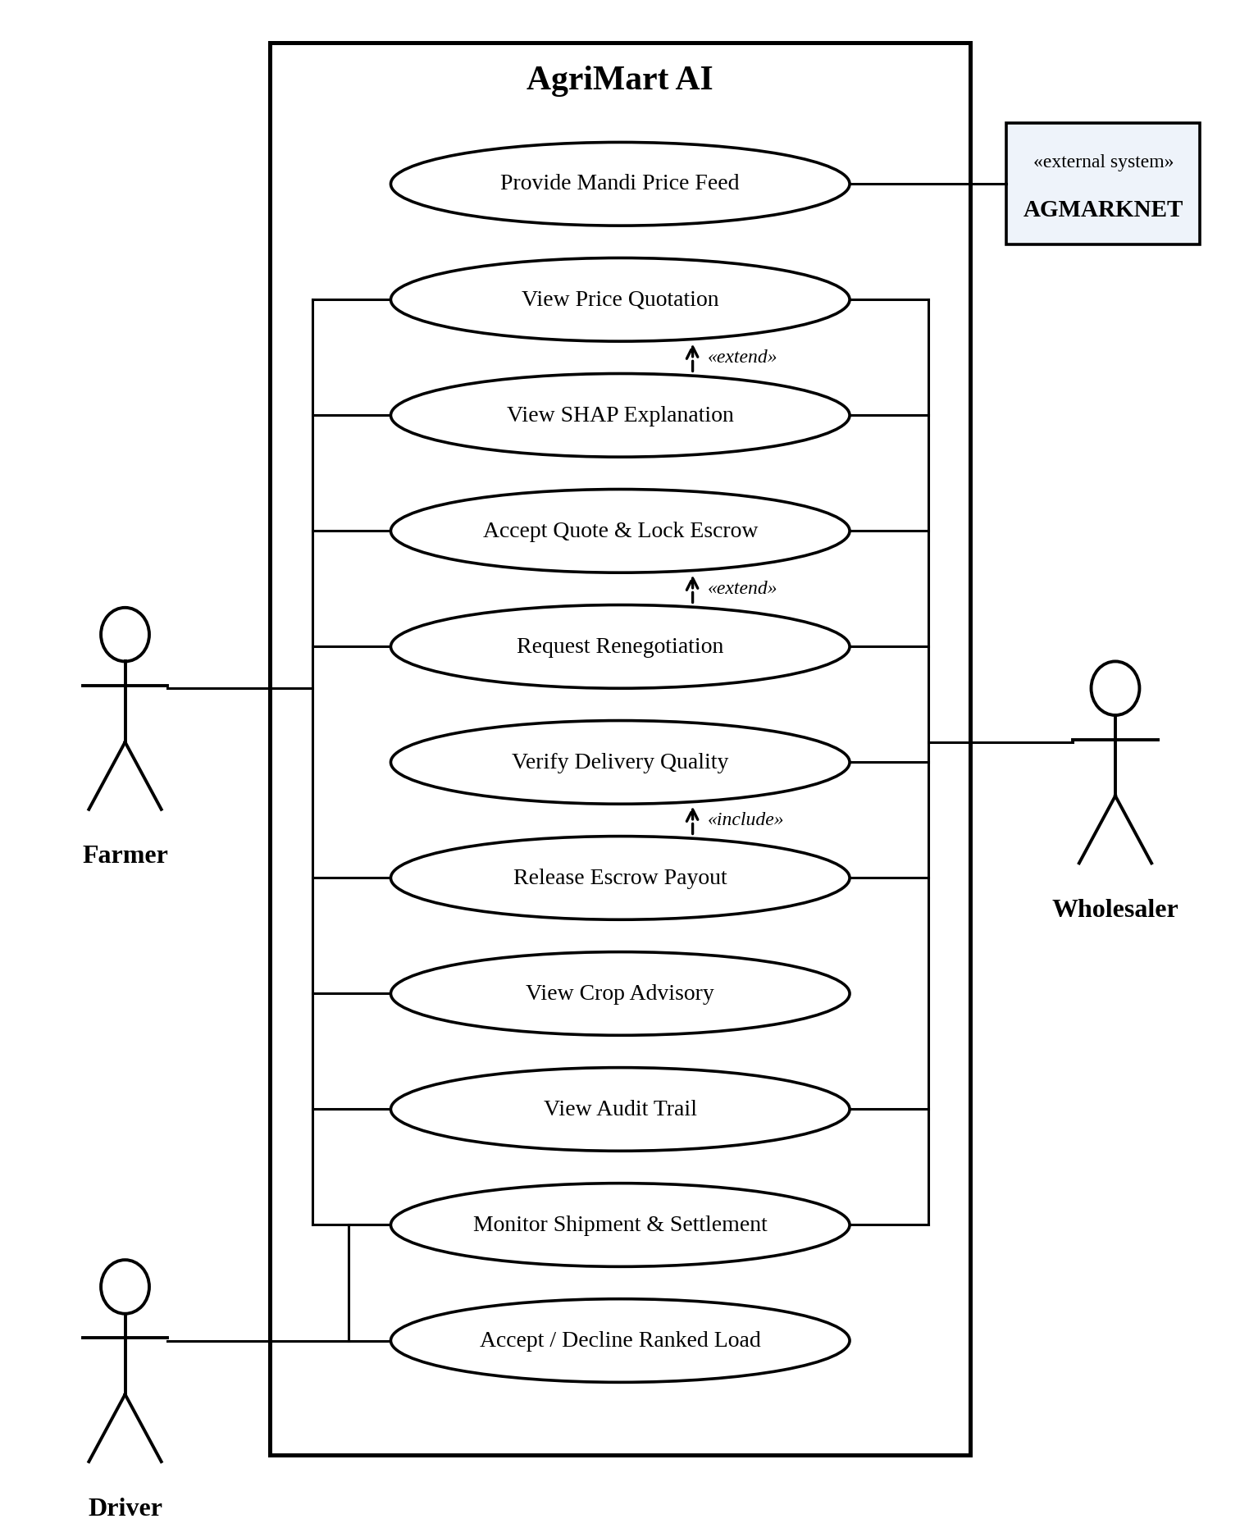
Figure 4.1: Use case diagram of the AgriMart AI platform
The use case diagram in Figure 4.1 shows the functional scope of AgriMart AI from the point of view of the entities that interact with it, without describing how the functions are implemented. It follows standard UML notation: the actors are drawn as stick figures outside the system boundary, the use cases are drawn as ellipses inside the rectangle labelled “AgriMart AI”, solid lines show the association between an actor and a use case, and dashed arrows show the «include» and «extend» relationships.
The system has three human actors and one external system. The Farmer is the producer who receives the price quotation, decides whether to accept it, follows the shipment and the settlement, and consults the crop advisory. The Wholesaler is the buyer who takes part in the quotation and settlement, and who verifies the quality of the produce on delivery. The Driver is the transporter who receives ranked loads and either accepts or declines them. AGMARKNET is an external data source that provides the mandi price feed on which the forecasts are based.
The use cases View Price Quotation and Accept Quote & Lock Escrow are shared by the farmer and the wholesaler. View Price Quotation presents the price band produced by the STCE forecaster, and Accept Quote & Lock Escrow records the explicit acceptance and enters the agreed amount into the simulated escrow ledger. Monitor Shipment & Settlement lets the stakeholders follow the transit conditions and the rule-based settlement, and Accept / Decline Ranked Load is the step in which the driver accepts or denies the load that has been ranked highest for him. Verify Delivery Quality records the arrival of the produce and its quality check, Release Escrow Payout pays out the simulated escrow, View Crop Advisory shows the ranked crops for the next season, and View Audit Trail lets the stakeholders examine the full sequence of decisions.
Three relationships are shown between the use cases. The «extend» relationship indicates an optional extension of a base use case: View SHAP Explanation extends View Price Quotation, because the explanation is an optional addition to the quotation, and Request Renegotiation extends Accept Quote & Lock Escrow, because it happens only when a stakeholder does not accept the quoted band. The «include» relationship indicates that one use case always uses another: Release Escrow Payout includes Verify Delivery Quality, which means that the escrow can never be released without the quality gate.

4.2 DATA FLOW DIAGRAM
The system uses a carefully constructed pipeline to transform raw historical mandi data into price quotations, settlements and payouts in a transparent way. Figures 4.2 and 4.3 show the data flow in two parts: the first part covers data preparation, forecasting and quotation, and the second part covers settlement, logistics, escrow and advisory.
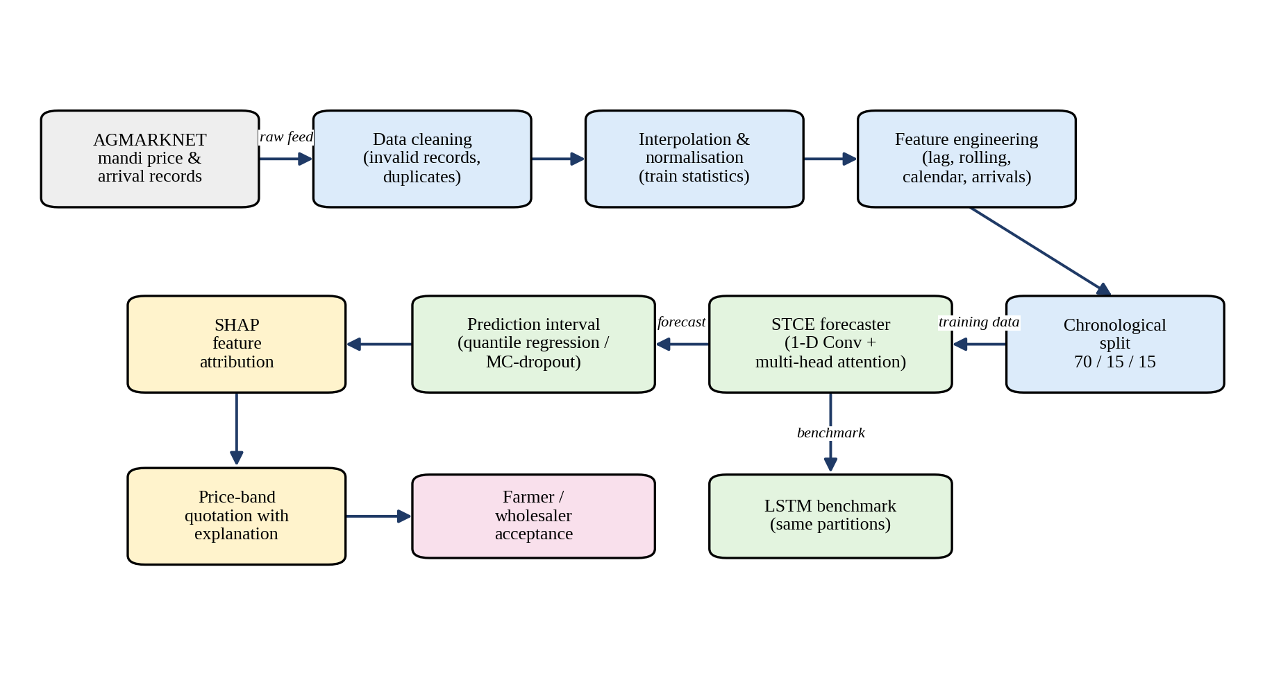
Figure 4.2: Data flow diagram (forecasting and quotation)
The data flow starts with the ingestion of the daily mandi price and arrival records from AGMARKNET. In the cleaning stage, non-numeric or non-positive price and arrival values and records in which the minimum price exceeds the maximum price are removed. The series is then re-indexed to a continuous daily calendar, missing days are filled by interpolation, and the numerical features are normalised with statistics computed on the training set only. Feature engineering adds lagged prices, rolling statistics, arrival volume and calendar features, and the data is split chronologically into training, validation and test partitions.
The STCE forecaster is trained on the training partition, while the LSTM is trained on the same partitions as the benchmark. The forecaster output is turned into a prediction interval by quantile regression or Monte Carlo dropout, and SHAP attributes the predicted price to the input features. The result is a price-band quotation with an explanation, which the farmer and the wholesaler explicitly accept before dispatch.
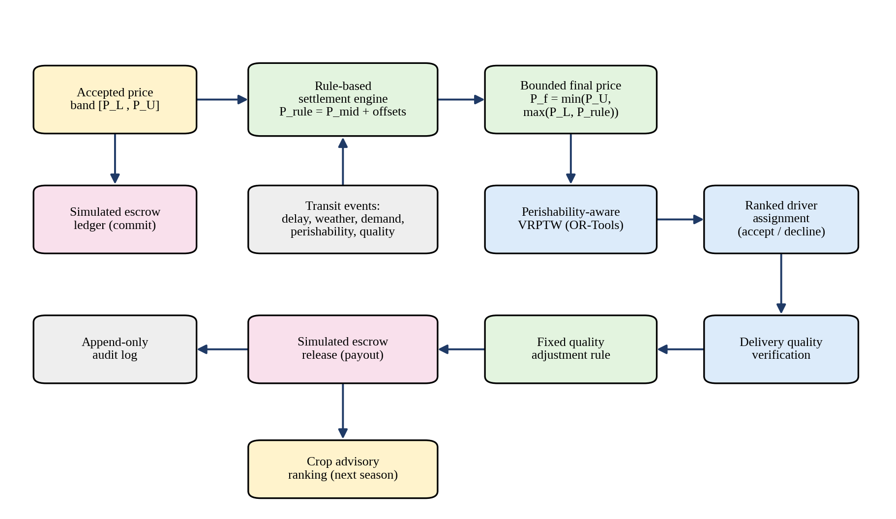
Figure 4.3: Data flow diagram (settlement, logistics and escrow)
After the acceptance, the agreed band [P_{L}, P_{U}] is stored in the simulated escrow ledger and passed to the rule-based settlement engine. The engine combines the band with the transit events (delay, weather, demand movement, perishability and quality state) and returns a bounded final price. In parallel, the perishability-aware VRPTW module builds feasible routes and the ranked driver assignment offers the loads to the drivers, who accept or decline them. At delivery, the quality verification is compared with the condition agreed before dispatch and a fixed adjustment rule is applied. The simulated escrow is then released according to the verified settlement, the whole sequence is written to the append-only audit log, and the outcome of the season is used by the crop advisory ranking for the next season.

CHAPTER 5
SYSTEM IMPLEMENTATION

5.1 SYSTEM ARCHITECTURE
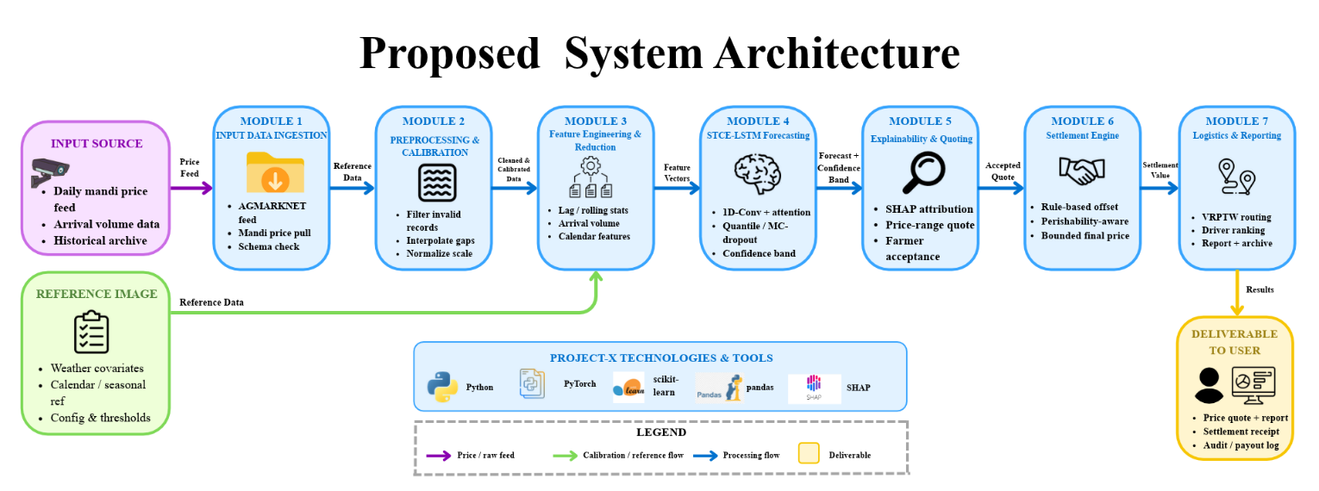
Figure 5.1: System architecture diagram of AgriMart AI
The proposed system employs a modular architecture in which the data flows from the input sources to the deliverables that are presented to the user. It comprises seven modules, which are described below. The input source supplies the daily mandi price feed, the arrival volume data and the historical archive. A reference input supplies weather covariates, calendar and seasonal references and the configuration and thresholds used by the system.
Module 1, Input Data Ingestion, pulls the mandi prices from the AGMARKNET feed and checks the schema of the incoming records. Module 2, Preprocessing and Calibration, filters invalid records, interpolates gaps and normalises the scale of the numerical variables. Module 3, Feature Engineering and Reduction, produces lag and rolling statistics, arrival volume and calendar features from the cleaned data.
Module 4, STCE-LSTM Forecasting, applies a one-dimensional convolution followed by attention to the feature vectors and generates the forecast and the confidence band with quantile regression or Monte Carlo dropout. Module 5, Explainability and Quoting, applies SHAP attribution, issues the price-range quote and records the acceptance of the farmer. Module 6, the Settlement Engine, applies the rule-based offset with perishability awareness and returns the bounded final price. Module 7, Logistics and Reporting, performs the VRPTW routing and the driver ranking and produces the report and the archive. The deliverables to the user are the price quote with its report, the settlement receipt and the audit and payout log. The implementation uses Python, PyTorch, scikit-learn, pandas and SHAP.

5.2 PREPROCESSING AND FEATURE EXTRACTION

5.2.1 DATA PREPROCESSING
Dataset Acquisition: The primary market information is sourced from the Open Government Data platform of the Government of India, using the resource “Current Daily Price of various commodities from various markets (Mandi)” that is available through the AGMARKNET link. The resource gives market-level commodity price information and is linked to the National Informatics Centre and the information package of the agricultural market. The daily mandi price records are sorted by commodity, market, variety and date along with the reported price, and the arriving volumes are kept as an explanatory market-pressure variable.
Experimental Data: For the experimental study reported in Chapter 7, records were drawn from the AGMARKNET-sourced daily mandi price archive for Soyabean at the Itarsi market (Madhya Pradesh), spanning January 2008 to June 2017. A total of 2,718 raw variety-level records were retrieved for this commodity-market pair. During preprocessing, 52 invalid observations were removed (non-numeric or non-positive price or arrival fields, and records in which the reported minimum price exceeded the maximum price), and no exact duplicate records were found in this subset. The remaining 2,666 records were aggregated into 2,359 distinct arrival-weighted daily trading records. Re-indexing to a continuous daily calendar and interpolating the 1,101 non-trading or missing calendar days produced a final continuous daily series of 3,460 records, which was used for model training, validation and testing. Figure 5.2 shows the dataset preprocessing summary.
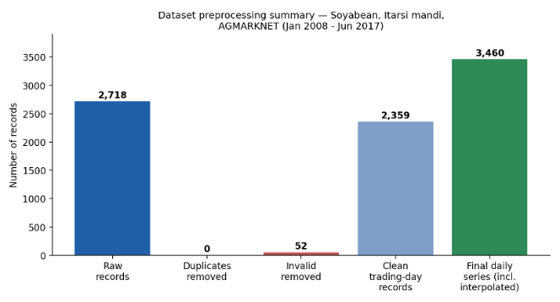
Figure 5.2: Dataset preprocessing summary (Soyabean, Itarsi mandi, AGMARKNET, Jan 2008 - Jun 2017)
Handling Missing Values: Duplicate records are eliminated, invalid observations are filtered out, and missing values are interpolated with time-based interpolation or, for operational reasons, forward filled. Weather observations comprise temperature and precipitation, and price change characteristics are used as demand indicators in the full system design. For the experiment reported here, weather covariates were not available for this specific commodity-market series, so the demonstrated model uses price-, arrival- and calendar-derived features, and the weather integration remains part of the full system design for future data collection.
Feature Normalization: Categorical features are encoded and numerical features are normalised using the statistics of the training set only, and the same statistics are then applied to the validation and test sets. The chronological ordering is maintained so that no future information flows into the model training process.
Dataset Partitioning: To ensure a robust evaluation and to prevent information leakage, the preprocessed data is partitioned chronologically and not randomly, because agricultural prices are time dependent. The first 70% of the observations form the training set, which is used to learn the parameters of the models. The next 15% form the validation set, which is used for hyperparameter selection and early stopping. The remaining 15% form the test set, which is reserved for the final, unbiased evaluation and is not used until the forecasting architecture, the configuration of the confidence bands and the settlement-rule parameters are fixed.

5.2.2 FEATURE EXTRACTION
Feature extraction transforms the preprocessed price and arrival series into an informative representation for the forecaster. In the experiment reported in this project, the feature set consists of price-, arrival- and calendar-derived features: the recent modal price, the minimum and maximum price of the day and the daily price range, the one-day and seven-day lagged prices, the seven-day rolling mean and standard deviation of the price, the arrival volume and its seven-day rolling mean, and the day of the week and the month as calendar features.
The input to the model is a sequence of these feature vectors of length L that ends at time t. Instead of engineering the temporal patterns manually, the STCE learns them: the convolutional layer extracts the local temporal patterns of each feature sequence and the attention mechanism relates distant positions of the sequence. In the full system design, further variables such as weather, demand, distance, route condition and perishability are added to the feature vector of each load, so that the resulting price interval is specific to that load.

5.3 SINGLE-LAYER TRANSFORMER CONVOLUTIONAL ENCODER (STCE) MODEL

5.3.1 OVERVIEW OF STCE ARCHITECTURE
Within the predictive component of AgriMart AI, the Single-Layer Transformer Convolutional Encoder (STCE) is the primary predictive architecture and is benchmarked against a standard Long Short-Term Memory (LSTM) network. The STCE first applies a one-dimensional convolutional operation over the sequential market features to extract local temporal patterns. A multi-head attention mechanism then captures the long-range contextual relationships among the historical prices, the market arrivals, the weather elements and the load-specific attributes. The resulting representation is fed to a prediction block that produces the main forecast together with a set of uncertainty intervals.
P_{t} = f_{STCE}( X_{t−L:t} ) (1)
where P_{t} is the predicted price at time t, X_{t−L:t} denotes the input sequence of length L, and f_{STCE} represents the proposed forecasting model. A standard LSTM is employed as the benchmark for the comparative evaluation and is trained on the same training and validation partitions. The performance of the models is assessed with RMSE, MAE, MAPE and the coverage of the prediction intervals, and the forecasts are evaluated at load time and at longer horizons, so that the immediate usefulness of the pricing signal and its temporal robustness are both assessed.

5.3.2 CONFIDENCE BAND GENERATION
The uncertainty of the forecast is represented by a prediction interval. Depending on the implementation configuration, the interval is constructed with one of two methods: quantile regression, in which the lower and upper quantiles of the price distribution are predicted directly, or Monte Carlo dropout, in which repeated stochastic forward passes are used to estimate the spread of the prediction. The confidence limits of the interval at time t are written as CI_{t} = [ Q_{α}(X_{t}), Q_{1−α}(X_{t}) ].
The quality of the interval matters as much as the accuracy of the point forecast. A narrow interval may look attractive because it allows narrow quotations, but it leaves farmers and wholesalers exposed to unexpected market fluctuations. A very wide interval gives high protection but not much price advantage. AgriMart AI therefore does not treat the interval as a statistical by-product but as an operational requirement: the target is an empirical coverage close to the nominal 90-95%, and the interval, once accepted by both parties, becomes the contractual boundary for the settlement.

5.3.3 EXPLAINABILITY AND PRE-COMMITMENT ESCROW
After the forecasting, explainability is used to state the price quote together with an interpretation that justifies the forecast. SHAP quantifies the contribution of each input feature to each prediction, giving farmers and wholesalers a transparent basis for the quoted price range. Features such as the recent price of the mandi, the arrival volume, the distance, the rainfall, the demand movement and the route difficulty are presented in an understandable form. Instead of an ambiguous point estimate, the farmer is given the range of prices of the forecast and accepts the quotation explicitly before dispatch.
The agreed amount is entered into a simulated internal escrow ledger on the day of acceptance. The escrow is not a real financial transaction; it is a state of commitment that is managed by software. The audit log tracks the quotes that were generated, the agreement of the user, the creation of the shipment, the time at which the escrow became active, the events in transit, the time at which the load was placed in inspection, any adjustment that was made and the payout status.

5.4 RULE-BASED SETTLEMENT ENGINE
The Settlement Engine determines the final transaction value for the farmer, the wholesaler and, optionally, the driver by using a deterministic rule set instead of a learned negotiation policy. The inputs of the rule set are the agreed lower and upper price boundaries, the current market movements, the Crop Perishability Index, the elapsed transit time, the weather conditions, the demand movement, the delay information and the quality-related state variables.
These operating parameters are combined by a weighted-adjustment mechanism into one settlement offset, which moves the price towards the lower limit when there is a serious risk of spoilage, or towards the upper limit when demand is high and serious transit delays occur. The explicit weighting parameters are tuned empirically on the validation sets in order to keep the balance and to avoid a systematic bias towards either farmers or wholesalers. Because each adjustment is calculated with a clear and public formula, the settlement value is reproducible and easily explained to farmers and wholesalers. The intermediate price is calculated with a linear multi-factor formula that adjusts the middle price of the agreed band:
P_{mid} = ( P_{L} + P_{U} ) / 2 (2)
P_{rule} = P_{mid} + w₁·Δ_{demand} − w₂·Δ_{delay} − w₃·S_{spoilage} − w₄·Q_{dev} (3)
P_{f} = min( P_{U}, max( P_{L}, P_{rule} ) ) (4)
where P_{f} is the final settlement price, P_{L} and P_{U} are the lower and upper bounds of the agreed range, P_{rule} is the price determined by the rule-based settlement engine, w₁ to w₄ are the weighting parameters, and Δ_{demand}, Δ_{delay}, S_{spoilage} and Q_{dev} are the demand shift, the transit delay, the spoilage index and the quality deviation. Equation (4) guarantees that the final settlement price always lies within the price band agreed in advance, and every price input variable and offset is recorded in the audit trail.

5.5 PERISHABILITY-AWARE VRPTW AND DRIVER ASSIGNMENT
The classical Vehicle Routing Problem with Time Windows formulation is adopted for the transportation problem. Google OR-Tools is used to obtain feasible and efficient routes based on the vehicle capacity, the pickup and delivery locations, the delivery deadline and the travel time. Attributes such as the route conditions and the perishability of the crop are also considered. The Crop Perishability Index adjusts the urgency of the assignment of a shipment, so that loads with a higher risk of deterioration receive a stronger priority. The objective of the routing is expressed as:
min Z = C + λD + μS (5)
where C is the transportation cost, D is the delivery delay, S is the spoilage risk, and λ and μ are weighting factors.
The reputation of a driver is integrated as a ranking function based on the past punctuality and the dispute behaviour of the driver. The resulting ranked pull model shows the appropriate loads to the drivers. The top-ranked load is highlighted, and the driver can accept or deny it. Repeated declines can lower the priority of the driver in subsequent rankings. Two system-level operational metrics are captured: the assignment-to-pickup time and the recommendation acceptance rate. Upon delivery, the crop quality is verified and the settlement is adjusted accordingly.

5.6 QUALITY VERIFICATION, SETTLEMENT AND ADVISORY
The system records the confirmation of the arrival of the load at delivery and includes a manual or photo-assisted quality check. The verification result is compared with the quality condition that was agreed before the receipt, and a fixed adjustment rule is applied if the delivered condition differs from the agreed one. The modified amount is then used to pay out the simulated escrow. An audit record of the entire transaction is maintained in an append-only manner, so that the full sequence of decisions can be examined by the stakeholders.
Crop advisory uses an independent, rule-based ranking function, in which the opportunities for the next season are scored by combining the expected demand, the cultivation cost and the price trend and cultivation likelihood indicators into a single ranking score. The candidate crops are ranked by this score to support the decision of the farmer. The entire application is designed as a Progressive Web Application, so that the status of the transactions, the quotations and the advisory results can be used with low bandwidth and without a native mobile application. The complete pipeline is summarised in Algorithm 1.
Algorithm 1: Integrated Forecasting, Rule-Based Settlement, and Perishability-Aware Routing Pipeline
Data Preparation
1. Collect mandi price, arrivals, weather, demand, distance, route and perishability data.
2. Remove duplicates and invalid records, and handle missing values.
3. Encode categorical features and normalise numerical features.
4. Preserve chronological order and split the data into 70% training, 15% validation and 15% testing.
Price Prediction and Uncertainty
5. Construct sequential load-level features from market and contextual data.
6. Apply the STCE for local temporal and contextual feature extraction; use the LSTM as the comparative forecasting model.
7. Generate the predicted commodity price and the lower and upper confidence limits: P̂_{t} = f_{STCE}(X_{t−L:t}), CI_{t} = [Q_{α}(X_{t}), Q_{1−α}(X_{t})].
8. Evaluate RMSE, MAE, MAPE and interval coverage, and apply SHAP to explain the predicted price.
Commitment and Rule-Based Settlement
9. Present the predicted price band to the farmer and the wholesaler, and store the accepted price range in the simulated escrow ledger.
10. Initialise the farmer, wholesaler and optional driver state variables.
11. Compute a weighted settlement offset from price, demand, weather, delay, quality and perishability states, and apply it to derive an acceptable settlement value.
12. Constrain the final settlement within the committed band, P_{f} = min(P_{U}, max(P_{L}, P_{rule})), and record the input states, the applied offset and the final value.
Perishability-Aware Routing
13. Calculate the crop urgency from the perishability and transit conditions.
14. Rank the available drivers using punctuality, dispute history and route suitability.
15. Formulate the VRPTW with vehicle capacity, pickup, delivery and time-window constraints, and generate the feasible efficient route with OR-Tools.
16. Offer the highest-ranked load to the driver, reassign the shipment when the driver declines, and monitor transit time, delay, weather and crop condition.
Quality, Escrow and Advisory
17. Verify the delivered quantity and crop quality at the destination and apply the predefined quality-based adjustment rule.
18. Release the simulated escrow according to the verified settlement.
19. Store the quotation, routing, negotiation, inspection and payout records, and calculate the delivery, spoilage, settlement and routing performance.
20. Rank the next-season crops using expected demand, price trend and cultivation cost, and display the forecast, settlement, shipment, payout and advisory results through the PWA.

CHAPTER 6
OUTPUT

6.1 PRICE FORECAST AND CONFIDENCE BAND
The most important output of the forecasting layer is the predicted price of the load together with its confidence band. For every day of the test period the STCE model outputs a point forecast and the lower and upper limits of the prediction interval. The point forecast indicates the expected mandi price, and the interval indicates the range in which the actual price is expected to fall, which is the range that is quoted to the farmer and the wholesaler.
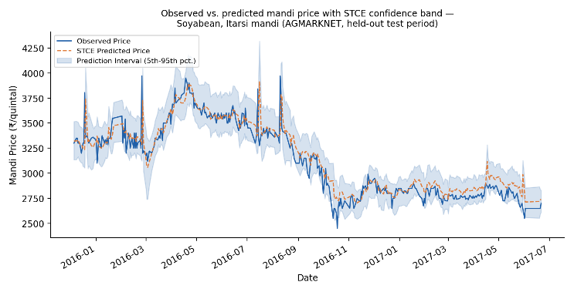
Figure 6.1: Observed versus predicted mandi price with the STCE confidence band (Soyabean, Itarsi mandi, held-out test period)
Figure 6.1 offers a qualitative assessment of the model on the held-out test partition. The observed price is shown by the solid line, the STCE prediction by the dashed line, and the shaded region is the 5th to 95th percentile prediction interval. The plot shows the temporal behaviour of the model beside the numbers of Table 7.1: the forecast follows the large movements of the observed price, such as the rise to a peak of roughly ₹4,000 per quintal in the middle of the test period and the subsequent decline, and there are periods in which the actual price moves beyond the estimated interval. Such periods are the reason why the interval coverage is monitored together with the point-forecast error.
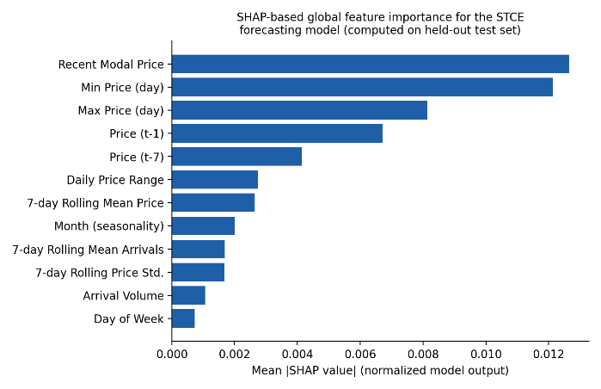
Figure 6.2: SHAP-based global feature importance for the STCE forecasting model (held-out test set)
Figure 6.2 shows the global SHAP feature importance computed from the trained STCE model on the held-out test set with a gradient-based SHAP explainer. The recent modal price, the minimum and the maximum price of the day, and the one-day and seven-day lagged prices are the most influential features. The daily price range, the rolling mean price, the month, the rolling mean of arrivals, the rolling price volatility, the arrival volume and the day of the week contribute more modestly. This is consistent with a market whose price dynamics are dominated by the recent price history at this mandi.

6.2 QUOTATION AND SETTLEMENT INTERFACE
The forecasts, the explanations and the simulation outputs are brought together in the interface that the farmer sees. Figure 6.3 illustrates how a single quotation ties the stages of the system together, populated with the real STCE point estimate and interval reported above and with the simulated settlement and routing figures reported in Table 7.2. It is an illustrative user-interface mockup and not a live production screenshot.
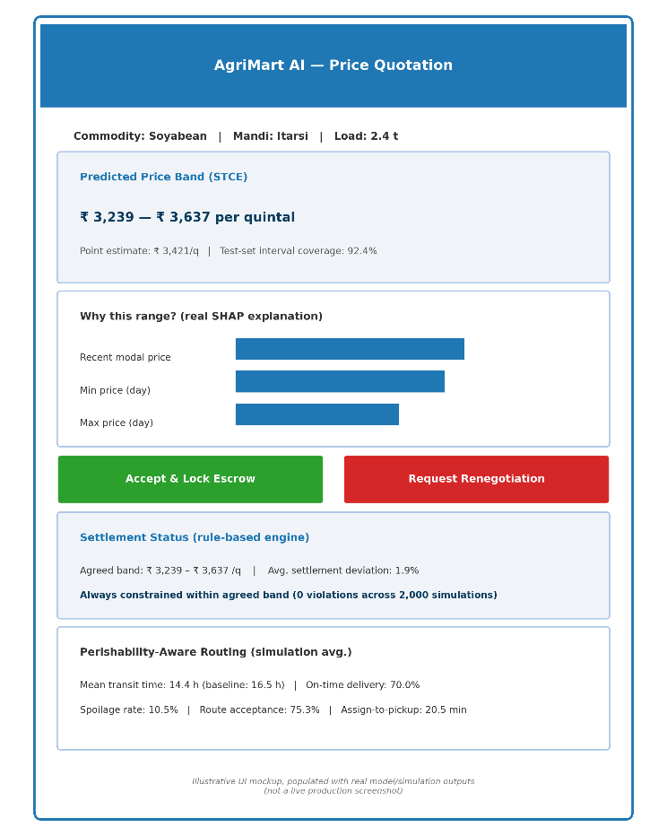
Figure 6.3: Illustrative price-quotation and settlement interface (UI mockup, not a live production screenshot)
The quotation card states the commodity (Soyabean), the mandi (Itarsi) and the load (2.4 t). It shows the predicted price band of ₹3,239 to ₹3,637 per quintal, the point estimate of ₹3,421 per quintal and the test-set interval coverage of 92.4%. Below it, the SHAP explanation lists the most influential factors, namely the recent modal price, the minimum price of the day and the maximum price of the day. The farmer can either accept the quote and lock the escrow, or request a renegotiation. The settlement status panel shows that the rule-based engine keeps the settlement inside the agreed band, with an average settlement deviation of 1.9% and no violations across the 2,000 simulations, and the perishability-aware routing panel shows the average simulated outcomes: a mean transit time of 14.4 hours (baseline 16.5 hours), an on-time delivery rate of 70.0%, a spoilage rate of 10.5%, a route-acceptance rate of 75.3% and an assignment-to-pickup time of 20.5 minutes.

CHAPTER 7
RESULTS AND DISCUSSION
This chapter describes the experimental setup, defines the performance metrics that are used for the evaluation, and discusses the results obtained for the forecasting layer and for the settlement and routing layers of AgriMart AI. The aim is to analyse the effectiveness of the models, to compare them with the relevant baselines and to interpret the findings in the context of agricultural price forecasting and transaction support.

7.1 EXPERIMENTAL SETUP
The experimental evaluation uses a chronological split and not a random split, because agricultural prices are time dependent and a random split can cause information leakage. The first 70% of the observations are used for training, the next 15% for validation and the remaining 15% for testing. Only the training and validation partitions are used for hyperparameter selection and early stopping, and the test partition is not used until the forecasting architecture, the configuration of the confidence bands and the settlement-rule parameters are fixed. The evaluation protocol is designed so that a forecast is judged with the information that is available when a quote is issued, at load time and at longer horizons of 30, 60 and 90 days, which is a better approximation of the real deployment.
The values reported in this chapter are from a real experiment. The models were trained and evaluated on the AGMARKNET daily price series for Soyabean at the Itarsi mandi described in Chapter 5, with 2,553 feature-engineered daily records and a chronological 70/15/15 split. The forecasting comparison includes a naive persistence baseline, an ARIMA(2,1,2) baseline, a GRU, an LSTM, an LSTM-GRU ensemble, the proposed STCE and an STCE variant with an additional uncertainty head.
Because a full end-to-end commercial deployment involves multi-stakeholder field adoption, the settlement and routing layers are evaluated as a controlled simulation benchmark. This benchmark evaluates whether the rule-based settlement engine consistently achieves stable compensation values while strictly honouring the price windows established before dispatch. A Monte Carlo simulation was conducted over 2,000 randomised shipment scenarios. For every simulated shipment, the price boundaries were drawn using the empirical prediction interval widths of the trained STCE forecaster, and the stochastic operational variables were sampled from predefined normal and uniform distributions calibrated to the historical mandi volatility: the transit delay Δ_{delay} follows a uniform distribution U(0, 6) hours, the spoilage index S_{spoilage} follows a normal distribution N(μ = 0.10, σ = 0.03) truncated between 0 and 1, the demand shift Δ_{demand} follows N(μ = 0.0, σ = 0.05), and the quality deviation Q_{dev} follows a uniform penalty scale U(0.0, 0.15).
The final experiment was run with Python 3.10, PyTorch 2.0.1, scikit-learn 1.2.2, SHAP 0.41.0 and Google OR-Tools 9.6 on an Intel Core i7 workstation with 16 GB RAM and an NVIDIA RTX-series GPU with 6 GB VRAM, under Ubuntu Linux. The STCE forecaster was trained for 100 epochs with the Adam optimiser, an initial learning rate of 0.001, a batch size of 32, the mean-squared-error (MSE) loss function and a fixed random seed of 42. The chief source of market data is the website of the Government of India, which contains the mandi-price information linked to AGMARKNET.

7.2 PERFORMANCE METRICS
The forecasting accuracy of the models was assessed quantitatively with four metrics. The Root Mean Square Error (RMSE) is the square root of the average of the squared errors, and it penalises large errors more heavily. The Mean Absolute Error (MAE) is the average magnitude of the errors, without considering their direction. The Mean Absolute Percentage Error (MAPE) expresses the error as a percentage of the actual value. The interval coverage is the percentage of actual prices that fall inside the predicted interval [L_{i}, U_{i}] and is compared with the nominal 90-95% target.
RMSE = √[ (1/n) Σ ( y_{i} − ŷ_{i} )² ] (6)
MAE = (1/n) Σ | y_{i} − ŷ_{i} | (7)
MAPE = (100/n) Σ | ( y_{i} − ŷ_{i} ) / y_{i} | (8)
Coverage = (100/n) Σ 1[ L_{i} ≤ y_{i} ≤ U_{i} ] (9)
The settlement and routing layers were evaluated with eight metrics: the mean settlement deviation from the agreed midpoint, the standard deviation of the settlement price, Jain’s fairness index, the mean transit time, the on-time delivery rate, the spoilage or waste rate, the route-acceptance rate and the assignment-to-pickup time. Jain’s fairness index, J = (Σ x_{i})² / (n Σ x_{i}²), lies between 1/n and 1, and a value close to 1 indicates that the outcomes are distributed equitably.

7.3 QUANTITATIVE RESULTS
The primary quantitative findings are given in two tables and one figure. Table 7.1 presents the forecasting performance on the held-out test set alongside the baselines.
Table 7.1: Forecasting performance on the held-out test set (Soyabean, Itarsi mandi, AGMARKNET)
Model | RMSE (₹/q) | MAE (₹/q) | MAPE (%) | Interval Coverage (%)
Naive (persistence) | 115.97 | 68.06 | 2.12 | N/A
ARIMA(2,1,2) | 103.21 | 62.87 | 1.96 | N/A
GRU | 112.34 | 66.24 | 2.09 | 89.24
LSTM | 110.16 | 66.92 | 2.11 | 89.80
LSTM-GRU Ensemble | 110.67 | 66.08 | 2.09 | 89.52
STCE (proposed) | 120.23 | 78.94 | 2.55 | 92.35
STCE + uncertainty head | 125.63 | 87.00 | 2.78 | 63.74

On this series, ARIMA and the LSTM-based models achieve marginally lower point-forecast errors (RMSE, MAE and MAPE) than the STCE, while the STCE attains the interval coverage that is closest to the nominal 90-95% target, at 92.35%. This is consistent with the framing of this project that the central contribution is the integrated decision chain and not a claim of outright forecasting superiority for any single algorithm. It also suggests that, for series with a strong day-to-day persistence, simpler statistical baselines remain competitive, and that a production deployment should benchmark the STCE against them on a per-commodity basis before selecting a forecasting engine. The STCE variant with an additional uncertainty head reached a coverage of only 63.74% in this experiment, which shows that the calibration of the interval is sensitive to the way the uncertainty is modelled and must be checked together with the point error.
The result also shows why interval coverage should be considered together with the point-forecast error. A narrow prediction interval may seem appealing because it allows narrow quotations, but it leaves farmers and wholesalers vulnerable to unexpected market fluctuations. On the other hand, a large interval gives high protection but not much price advantage. The system therefore uses the interval quality as an operational requirement and not only as a statistical output.
Table 7.2 reports the comparison between the unstructured baseline and AgriMart AI in the Monte Carlo simulation of 2,000 shipments, and Figure 7.1 shows the same comparison graphically with each metric normalised to the larger of the two values.
Table 7.2: Settlement and routing evaluation (Monte Carlo simulation, N = 2,000 shipments)
Metric | Baseline | AgriMart AI
Mean settlement deviation from agreed midpoint (%) | 6.82 | 1.92
Settlement price standard deviation (₹/q) | 571.25 | 486.12
Jain’s fairness index | 0.98 | 0.99
Mean transit time (h) | 16.46 | 14.41
On-time delivery rate (%) | 67.6 | 69.95
Spoilage/waste rate (%) | 26.65 | 10.5
Route-acceptance rate (%) | 48.9 | 75.25
Assignment-to-pickup time (min) | 54.02 | 20.53

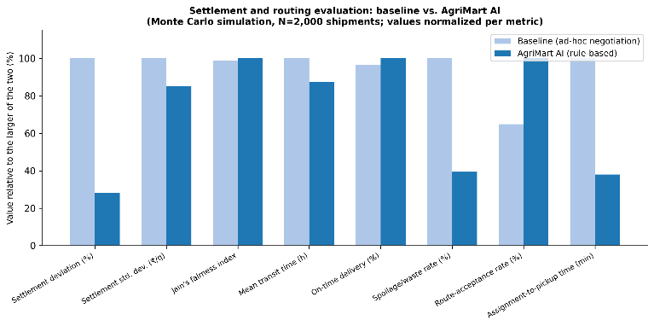
Figure 7.1: Settlement and routing evaluation: baseline vs. AgriMart AI (Monte Carlo simulation, N = 2,000 shipments)
The settlement consistency, in terms of a lower deviation and a lower standard deviation, is higher under AgriMart AI than under the unstructured baseline, because the offset is computed deterministically from a fixed rule set instead of being negotiated ad hoc. The perishability-aware routing layer reduces the mean transit time, the spoilage or waste rate and the assignment-to-pickup time, while it increases the on-time delivery rate and the route-acceptance rate, relative to a perishability-agnostic, reputation-blind assignment baseline.
The routing results have to be interpreted in relation to perishability, because the purpose of the routing is not only to minimise distance. A geographically shorter route can actually be worse if it involves long waiting periods before harvest or an inappropriate delivery window for a highly perishable crop. The VRPTW formulation therefore concentrates on realistic delivery timetables, taking the perishability and the suitability of the drivers into account. The ranked pull workflow also provides an operating link between the optimisation and the behaviour of the drivers: the mathematical solver proposes an assignment, but the driver serves as the gate.
The main contribution at the system level is the combination of prediction and execution, and not the development of any specific algorithm. The forecasting layer generates a firm, bounded price commitment. The escrow workflow takes this commitment and implements it as an audited transaction state, the rule-based settlement engine adjusts the settlement without violating the commitment boundary, and the VRPTW handles the feasibility of the delivery. SHAP acts as the interpretability layer for the price recommendations and exposes the reasons behind them, while the rule-based settlement engine exposes the reasons behind every settlement adjustment by construction. The crop advisory module extends the system upstream by giving counselling on the expected market situation, in support of the next-season crop decisions. Together these elements form an unbroken line of communication from the pre-harvest planning to the post-delivery settlement.

CHAPTER 8
CONCLUSION AND FUTURE WORK

8.1 CONCLUSION
AgriMart AI serves as a comprehensive, unified decision-support platform across the agricultural supply chain, integrating price forecasting, contractual pre-commitment, automated settlement, logistics routing, quality verification and farmer advisory into one cohesive workflow. The foundational strength of the system lies in its capacity to transform standard price predictions into transparent, interpretable price bands that the stakeholders can review and approve before the shipment is dispatched.
The commitment is then carried through by the rule-based settlement mechanism, which lets the final market and transit conditions influence the final transaction while keeping the initial commitment boundary unchanged. The perishability-aware VRPTW extends the logistics to the economic aspects of the trade, and SHAP gives greater transparency to the end users. On the real AGMARKNET Soyabean series of the Itarsi mandi, the STCE forecaster achieved an RMSE of ₹120.23 per quintal, a MAPE of 2.55% and an interval coverage of 92.35%, and although the ARIMA and the LSTM-based baselines were marginally better in point-forecast error, the STCE gave the coverage closest to the nominal target. In the Monte Carlo simulation of 2,000 shipments, the settlement deviation from the agreed midpoint fell from 6.82% to 1.92% and the spoilage or waste rate from 26.65% to 10.5%.
The system is designed to work in a practical implementation with limited connectivity and without any real financial infrastructure, using a simulated escrow. The manual quality verification and the simulated logistics data remain key constraints. The framework as a whole supplies a secure base for tying predictive farming intelligence to the secure execution of transactions and to supply chain management for perishable goods.

8.2 FUTURE ENHANCEMENTS
Building on the foundation of this work, several directions can be explored to increase the capability and real-world usefulness of the system.
Real Payment Integration: The simulated escrow can be replaced by real payment gateways, so that the quality-gated release of payment operates on real financial transactions with the same audit trail.
Automated Quality Grading: The manual or photo-assisted quality verification can be extended with automated, computer-vision-based quality grading of samples, which would make the quality gate faster and more consistent.
Richer Data and Multi-Market Evaluation: Adding more fleet data would strengthen the routing and assignment layers, and the integration of weather covariates, which were not available for the demonstrated series, would allow the full feature set of the system design to be used. Larger multi-market and multi-commodity experiments would allow the STCE to be benchmarked against the simpler statistical baselines on a per-commodity basis, and field tests would help to validate the economic benefits and the user acceptance.
Federated and Learning-Based Approaches: Federated learning across the regions of the country could allow models to be trained on regional data without centralising it, and learning-based routing could complement the OR-Tools formulation used at present.

REFERENCES
[1] C. E. A. Bundak et al., “Computationally Efficient Single Layer Transformer Convolutional Encoder for Accurate Price Prediction of Agriculture Commodities,” IEEE Access, vol. 13, pp. 82144–82159, 2025, doi: 10.1109/ACCESS.2025.3567903.
[2] H. Wang, W. Li, Z. Z. Zhao, Z. F. Wang, M. H. Li, and D. F. Li, “Intelligent Distribution of Fresh Agricultural Products in Smart City,” IEEE Transactions on Industrial Informatics, vol. 18, no. 2, pp. 1220–1230, 2022, doi: 10.1109/TII.2021.3096795.
[3] S. M. Lundberg and S.-I. Lee, “A Unified Approach to Interpreting Model Predictions,” in Advances in Neural Information Processing Systems (NeurIPS 2017), vol. 30, 2017, pp. 4765–4774.
[4] S. P. Raja, B. Sawicka, Z. Stamenkovic, and G. Mariammal, “Crop Prediction Based on Characteristics of the Agricultural Environment Using Various Feature Selection Techniques and Classifiers,” IEEE Access, vol. 10, pp. 23625–23641, 2022, doi: 10.1109/ACCESS.2022.3154350.
[5] N. A. R., I. M., T. D., and S. G., “Intelligent deep learning framework for real-time agricultural price prediction using NBEATS-X,” in 2025 4th International Conference on Automation, Computing and Renewable Systems (ICACRS), IEEE, 2025, pp. 1288–1293, doi: 10.1109/ICACRS67045.2025.11324187.
[6] D. Chen, B. Cheng, J. Li, Q. Shen, and J. Liu, “A study on the forecasting of agricultural product price trends based on SARIMA,” in 2025 IEEE 8th Information Technology and Mechatronics Engineering Conference (ITOEC), IEEE, 2025, pp. 441–445, doi: 10.1109/ITOEC63606.2025.10968760.
[7] M. Xia, “Machine learning-based agricultural product price fluctuation prediction and supply chain risk mitigation strategies,” in 2026 3rd International Conference on Integrated Intelligence and Communication Systems (ICIICS), IEEE, 2026, pp. 1–7, doi: 10.1109/ICIICS67880.2026.11483427.
[8] D. Zhang, S. Chen, L. Liwen, and Q. Xia, “Forecasting Agricultural Commodity Prices Using Model Selection Framework With Time Series Features and Forecast Horizons,” IEEE Access, vol. 8, pp. 28197–28209, 2020, doi: 10.1109/ACCESS.2020.2971591.
[9] Y. W. Syaifudin et al., “Deep learning with LSTM for agricultural commodity price prediction in Indonesia: From data collection to visual forecasting,” in 2025 6th International Conference on Data Analytics for Business and Industry (ICDABI), IEEE, 2025, pp. 1–9, doi: 10.1109/ICDABI67967.2025.11547603.
[10] J. N. Rao, N. Vineetha, D. Dinesh, and D. K. Sree, “Multilingual web-based agricultural decision support system: Integrating machine learning for accurate vegetable price prediction,” in 2024 International Conference on Inventive Computation Technologies (ICICT), IEEE, 2024, pp. 1001–1007, doi: 10.1109/ICICT60155.2024.10544612.
[11] Y. Wang, X. Wang, and L. Li, “EMD-TCN-TimeGAN: A Data Augmentation Model for Enhancing the Accuracy of Agricultural Product Price Prediction,” in 2024 IEEE International Conference on Big Data (BigData), IEEE, 2024, pp. 5161–5168, doi: 10.1109/BigData62323.2024.10825200.
[12] J. Feng, S. Wang, L. Zhang, and W. Mu, “Fruit price prediction method integrating temporal convolutional network and Transformer,” in 2026 7th International Conference on Big Data & Artificial Intelligence & Software Engineering (ICBASE), IEEE, 2026, pp. 659–668, doi: 10.1109/ICBASE70763.2026.11619499.
[13] M. U. Sarangapani, V. MuraliBhaskaran, S. M., and S. V. H., “A smart agricultural analytics and e-commerce framework for daily commodity price prediction using hybrid ARIMA-LSTM with improved TimeGAN,” in 2026 13th International Conference on Computing for Sustainable Global Development (INDIACom), IEEE, 2026, pp. 1–9, doi: 10.23919/INDIACom70271.2026.11525751.
[14] S. Fuentes, J. Oyague, J. L. Castillo-Sequera, and L. Wong, “Model for demand and price prediction of agricultural products in the Sacred Valley of Cusco applying machine learning algorithms,” in 2025 IEEE 4th International Conference on Computing and Machine Intelligence (ICMI), IEEE, 2025, pp. 1–6, doi: 10.1109/ICMI65310.2025.11141314.
[15] R. Kumar, P. Subha, S. R., R. M. D. Charaan, S. P. Santhoshkumar, and M. Sasikumar, “Precision price forecasting for agricultural commodities using AI-driven temporal models,” in 2025 2nd Asia Pacific Conference on Innovation in Technology (APCIT), IEEE, 2025, pp. 1–7, doi: 10.1109/APCIT65661.2025.11411508.
[16] Anonymous, “Smart Contracts for Managing the Agricultural Supply Chain: A Practical Case Study,” IEEE Access, 2024, doi: 10.1109/ACCESS.2024.3439412.
[17] R. Selvaraj, M. Sanmati, K. Sudharshan, R. Surithika, and S. Prasanth, “Demand prediction of agricultural crops using artificial intelligence,” in 2024 International Conference on Automation and Computation (AUTOCOM), IEEE, 2024, pp. 422–425, doi: 10.1109/AUTOCOM60220.2024.10486079.
[18] V. Bhuvanesh, P. S. Gowr, and M. Preethi, “Agrimetaverse intelligence advanced agricultural commodity price forecasting system,” in 2026 IEEE 1st International Conference on Intelligent Technologies for a Sustainable and Inclusive Future (ICITSIF), IEEE, 2026, pp. 147–152, doi: 10.1109/ICITSIF69060.2026.11608978.
[19] C. Feng, “Design of agricultural product price fluctuation warning algorithm based on hidden Markov model,” in 2024 International Conference on Telecommunications and Power Electronics (TELEPE), IEEE, 2024, pp. 449–454, doi: 10.1109/TELEPE64216.2024.00086.
[20] J. Liu, B. Zhang, T. Zhang, and J. Wang, “Soybean Futures Price Prediction Model Based on EEMD-NAGU,” IEEE Access, vol. 11, pp. 99328–99338, 2023, doi: 10.1109/ACCESS.2023.3314329.

APPENDICES
import numpy as np
import torch
import torch.nn as nn

# ---- Training configuration reported in Chapter 7 ----
SEED, EPOCHS, BATCH_SIZE, LR = 42, 100, 32, 1e-3
TRAIN_FRAC, VAL_FRAC = 0.70, 0.15 # chronological 70 / 15 / 15 split
torch.manual_seed(SEED); np.random.seed(SEED)

class STCE(nn.Module):
"""Single-layer Transformer-Convolutional Encoder with a forecast head.
d_model, n_heads and kernel are read from the experiment configuration."""
def __init__(self, n_feat, d_model, n_heads, kernel):
super().__init__()
self.conv = nn.Conv1d(n_feat, d_model, kernel, padding=kernel // 2) # local patterns
self.attn = nn.MultiheadAttention(d_model, n_heads, batch_first=True) # long-range context
self.norm = nn.LayerNorm(d_model)
self.head = nn.Linear(d_model, 1) # P_t

def forward(self, x): # x: (batch, L, n_feat)
h = self.conv(x.transpose(1, 2)).transpose(1, 2)
a, _ = self.attn(h, h, h)
return self.head(self.norm(h + a)[:, -1])

# ---- Rule-based settlement (Equations 2 to 4) ----
def settle(p_low, p_up, d_demand, d_delay, s_spoil, q_dev, w):
p_mid = (p_low + p_up) / 2.0
p_rule = (p_mid + w[0] * d_demand - w[1] * d_delay
- w[2] * s_spoil - w[3] * q_dev)
return min(p_up, max(p_low, p_rule)) # always inside the agreed band

# ---- Monte Carlo scenario sampling (Chapter 7.1) ----
def sample_scenarios(n, rng):
return dict(
delay=rng.uniform(0.0, 6.0, n), # hours
spoil=np.clip(rng.normal(0.10, 0.03, n), 0.0, 1.0),
demand=rng.normal(0.0, 0.05, n),
qdev=rng.uniform(0.0, 0.15, n),
)

# ---- Evaluation metrics (Equations 6 to 9) ----
def rmse(y, p): return float(np.sqrt(np.mean((y - p) ** 2)))
def mae(y, p): return float(np.mean(np.abs(y - p)))
def mape(y, p): return float(100 * np.mean(np.abs((y - p) / y)))
def coverage(y, lo, up): return float(100 * np.mean((y >= lo) & (y <= up)))

PRESENTATION CERTIFICATES
1st PAPER:


PUBLISHED SITE PAGE:
1st PAPER:
[Insert a screenshot of the published site page here]

PUBLISHED COPY:
1st PAPER:


